User Manual: Cybersecurity Training 2.0

By: Robert Hand (Team Leader), Valeria Gamboa, Matthew Sexton, Brandy Jordan

Table Of Contents

**Introduction** **3**

**General System Navigation** **3**

**Registration/Login/Logout** **5**

**Module Completion** **5**

**Viewing Progress** **5**

**Final Examination** **5**

**Getting the User’s Certificate** **5**

# Introduction

Cybersecurity Training 2.0 is a rather simple system to work with from a user’s perspective. However, it would still be good to have a resource for users to understand how to work with the system better. In this manual, we will go over the how to navigate the system, the registration/login process, how to complete a module, how to view your progress through the system, how to take (and hopefully pass!) the final exam, and how to get your certificate of completion of the course.

**Also of note, errors are in bold**.

# General System Navigation

The first subject that needs to be broached is the subject of what the user will be seeing over the course of using the system. The general layout of a web page for Cybersecurity 2.0 is something like this:

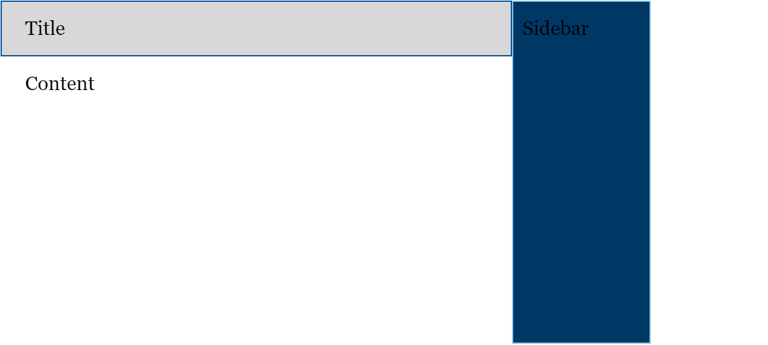

The title of the page will let you know which page you are on, the content of the page is what you go to that specific page for, and the sidebar lets you navigate to the rest of the system.

A user can navigate to most of the system naturally as soon as they register an account and are logged in; however, just because you can go to a page does not mean that you can use every feature that page has. You will not be able to take the final exam until you have finished all of the modules in the system. You will not be able to view, download, print, or email your certificate until you have completed the final exam. And finally, you will not be able to use pretty much any of the features unless you are logged into an account you made for yourself.

As the above paragraph said, there is a general linear flow through the system, it looks like:

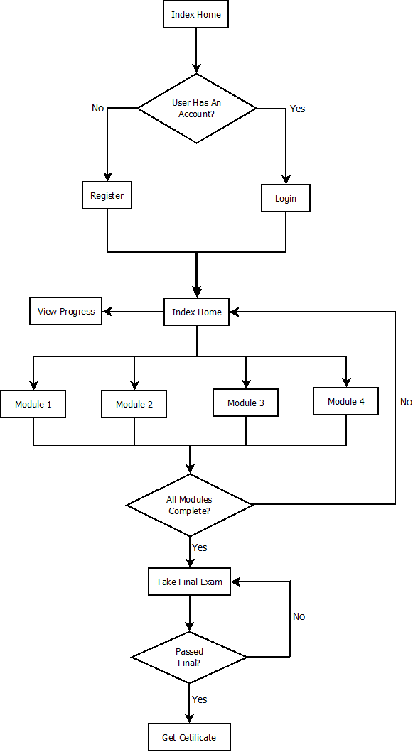

# Registration/Login/Logout

The registration and login features are generally familiar for most people. However, there are some rules to how our account feature works. On initial registration, there are some rules for the forms you need to fill out. Those rules are:

* Username is required
* Email address is required
* Password is required
* You need to enter your chosen password twice to confirm, therefore if the passwords do not match, that would be an error
* Username and Password cannot be the same
* Password must be at least 15 characters
* Username must be unique

If these rules are not met when the user tries to register a new account, they will be asked to fix the errors and resubmit. **Careful! The current system does not check if the user’s email is a valid address.**

Once a user is registered and logged into the system, the logout button will be located in a dropdown menu on the user’s name, which is located on the top of the sidebar.

If a user is logged out, they can log in again by going to the login page and entering their username and password.

# Module Completion

The way to complete a module is rather simple. The user simply navigates to the module’s page and then reads through the provided material. The user goes through the pages using the next and previous buttons at the bottom of the contents section. Once they get to the end, there is a short quiz game to test their knowledge. If they feel confident, they can click on the button to complete the course below the game.

**Careful! Using the previous/next buttons when you get to the game page can cause the game to bug out in weird ways (ex: the game doesn't show up any more or it fails to load).**

# Viewing Progress

Viewing a user’s progress is simple. If a user is logged in, they can go to the view progress page and see a yes/no on whether or not they have completed the various sections of the course.

# Final Examination

Once a user has completed every module, they can then go to the final exam page and answer the questions related to the modules that they just studied. If they get a 90% or higher, they pass! If a user passes, a certificate of completion is created for them that contains the time that they completed the final. If a user fails, they are encouraged to take the test again.

**Careful! The case where a user passes the test twice has not been fully tested, so errors may occur in that case.**

# Getting the User’s Certificate

Once a user has completed the final exam, if they go to the get certificate page, they can view, download, print, and email their certificate. The download and print features are simply the embedded pdf viewer the browser uses. Email is handled by a button appended to the bottom of the sidebar, clicking it brings up a form asking for the email address of the desired recipient of the certificate. Clicking send on the form will send an email with the certificate attached, the user will get an alert if the email was sent successfully.

**Careful! The case where a user attempts to send an email without a certificate created has not been tested, so errors may occur in that case.**